**Topic**

Looking at different types of transport.

* Find out facts about transport
* Who uses transport and what for? 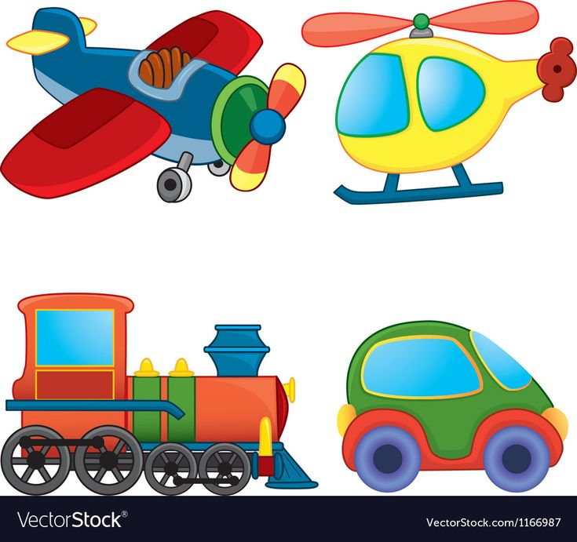

**Expressive Arts and Design**

* Using skills and imagination to create their own designs
* Drawing club
* Observational drawing
* Exploring clay
* Colour mixing

**Physical Development**

* Moving in different ways
* Use PE equipment with control, throwing and catching
* Putting on coats/shoes independently

**Understanding the World**

* Talking about changes in their life
* Pictures of the past
* Seasons/weather
* Forces
* People in the community and their roles

**Music**

* Singing Nursery rhymes and learning simple songs.
* Exploring instruments and their sounds.
* Kapow music – exploring sound

**Maths**

* Counting to 5 and beyond
* Comparing amounts
* Repeating patterns
* Sorting and matching
* Capacity, mass and length

**PSHE/R.E**

* Talking about ourselves
* Rules and routines
* Managing feelings
* Building friendships

**Literacy**

* Drawing Club
* Initial sounds
* Blending to read
* Segmenting to write
* Story structure – looking at beginning, middle and end

