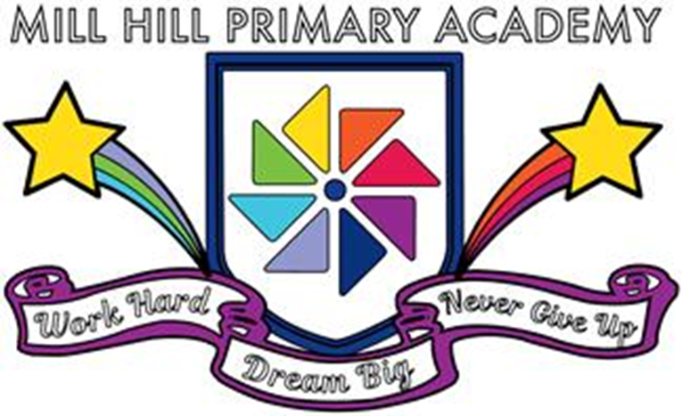

Pupil Premium Allocation 2021/2022

Pupil Premium Allocation 2021/2022: £296,795
Area of Focus | Budget Allocation | Overview
Breakfast Club and wrap around care Programme staffing | £9,212 | Staffing and learning activity resources
EWO additional support | £35,867 | Additional service level agreement for Education Welfare Officer targeted programmes and full time Attendance officer.
Attendance rewards programmes | £7,000 | Attendance rewards.  Attendance celebration event costs
Early Years additional support programmes | £25,240 | Staffing and resourcing costs for Early Years targeted intervention work
Intervention programmes in Phonics EY/KS1/LSK2 | £16.370 | Resources to support the implementation of the programme and part funded staffing costs.
Intervention to close gaps in learning | £20,679 | Part of staff salary to cover.
Careers, raising the aspirations of children | £5,000

Area of Focus | Budget Allocation | Overview
WISH Learning support assistants support costs | £82,559 | Funding for staff to support children in groups/individually for intervention programmes (KS, LR and TS)
SEND additional Support Programme staffing | £63,574 | LM, CG and 1 day per week SJ
Enrichment Activities | £2,000 | Resources and session leader costs
Instrumental Tuition Programme | £9,381 | Peripatetic music teacher costs
Behaviour for learning rewards programmes | £10,000 | Half termly/Termly reward activity practitioner and activity resource costs
Homework Club Resources | £1650 | Learning activity resources to support homework club - Planners
Uniform | £3,000 | Support funding for additional uniform
Learning resources | £12,000 | Budget which can be bid for, to support additional learning  opportunity programmes for PP pupils
Total Allocated | £296,795.00
Total Amount Spent | £296,795.00

